2. Image Processing Pipeline Components (Industry-Level Detail)
In regulated medical AI systems (e.g., potential SaMD under MHRA guidance), the image processing pipeline is the critical first stage ensuring secure, compliant handling of sensitive data. It focuses on ingestion of clinical formats and rigorous anonymisation to comply with UK GDPR, Data Protection Act 2018, and NHS IG Toolkit requirements. No real patient data is stored or processed beyond temporary anonymised instances; all operations are logged for auditability.
This pipeline is implemented as modular Python code (e.g., in /backend/image_processing/), using standard libraries to ensure reproducibility and verifiability.
Key Technologies and Implementation
- Primary Library: pydicom (for DICOM parsing/editing) + numpy/opencv-python (for pixel-level operations).
- Alternative Toolkits: Optional integration with GDCM (via gdcm Python wrapper) or dcmtk (via subprocess) for advanced cases.
- Support for Formats:
  - Primary: DICOM (.dcm) – full support for multi-frame, enhanced DICOM, etc.
  - Secondary: NIfTI (.nii/.nii.gz) – for processed/segmented outputs from prior steps (using nibabel).
- Secure Ingestion:
  - Files uploaded via secure endpoint (e.g., Flask/FastAPI with HTTPS, authentication).
  - Validation: Check SOP Class UID, Transfer Syntax; reject invalid/non-medical files.
  - Temporary in-memory processing; no persistent storage of originals.
Automated Anonymisation Script/Tool
Core module: anonymizer.py – applies a configurable profile.
Best Practices Implemented (Aligned with Standards):
- Strictly follows DICOM PS3.15 Security and System Management Profiles – Basic Application Level Confidentiality Profile (2024 version):
  - Remove or replace all PHI (Protected Health Information) attributes (Option: Clean Pixel Data + Clean Recognizable Visual Features).
  - Key actions: Delete (Action D), Replace with dummy (Z/D), Empty (X), Keep if safe (K).
- Specific handling:
  - Remove/replace: Patient Name, Patient ID, Patient Birth Date, Institution Name/Address, Referring Physician, Accession Number, etc.
  - UID handling: Generate new Study/Series/SOP Instance UIDs (using pydicom.uid.generate_uid()).
  - Date/Time: Shift all dates by a consistent random offset (e.g., +random days between 1-365) to preserve intervals but obscure absolutes.
  - Retain clinical essentials: Modality, Series Description, Body Part Examined, Protocol Name (unless they contain PHI).
- Burned-in Annotations Removal:
  - Detect and blackout text/identifiers burned into pixels (common in secondary captures).
  - Method: Use OpenCV with OCR (Tesseract via pytesseract) to locate text regions, then apply black rectangles or inpainting.
  - Fallback: Heuristic masking of common overlay areas (top-left/right corners, bottom strips).
Industry-Level Example Diagrams and Visuals
Figure 14: TCIA-standard image de-identification and processing pipeline flowchart (Comprehensive end-to-end anonymisation flow – adapt for your ingestion + pixel cleaning.)
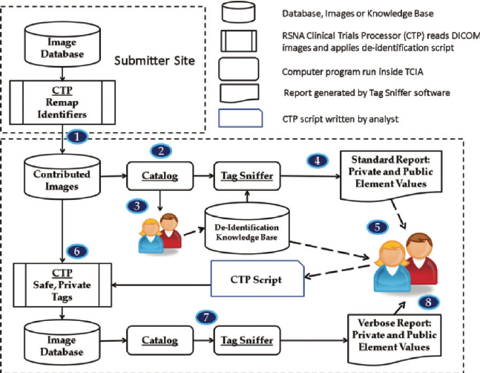
researchgate.net
TCIA image de-identification process. Flowchart shows image ...
Figure 15: DICOM big data management and anonymisation pipeline (Shows ingestion, metadata handling, and de-identification steps.)
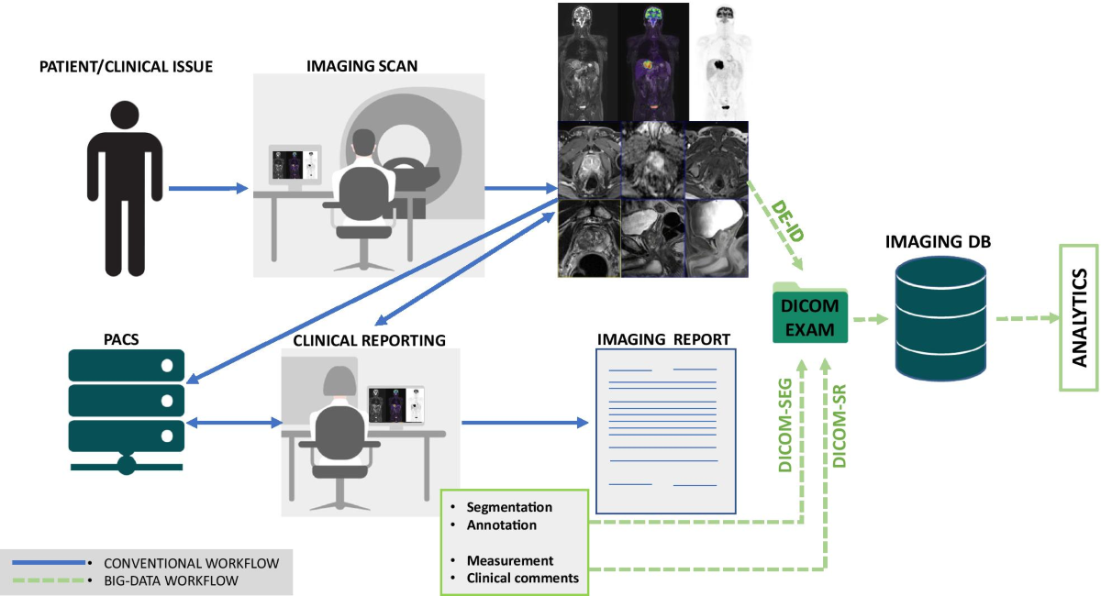
link.springer.com
How does DICOM support big data management? Investigating its use ...
Figure 16: Official DICOM PS3.15 Basic Application Level Confidentiality Profile process (Direct reference from NEMA standard – core compliance diagram.)

dicom.nema.org
PS3.15
Figure 17: Example of burned-in annotations removal (before/after blackout using OpenCV techniques) (Highlights pixel-level de-identification for overlays.)

physicamedica.com
Data preparation for artificial intelligence in medical imaging: A ...
Figure 18: Before/after DICOM header anonymisation example (pydicom-style) (Demonstrates PHI removal from metadata.)
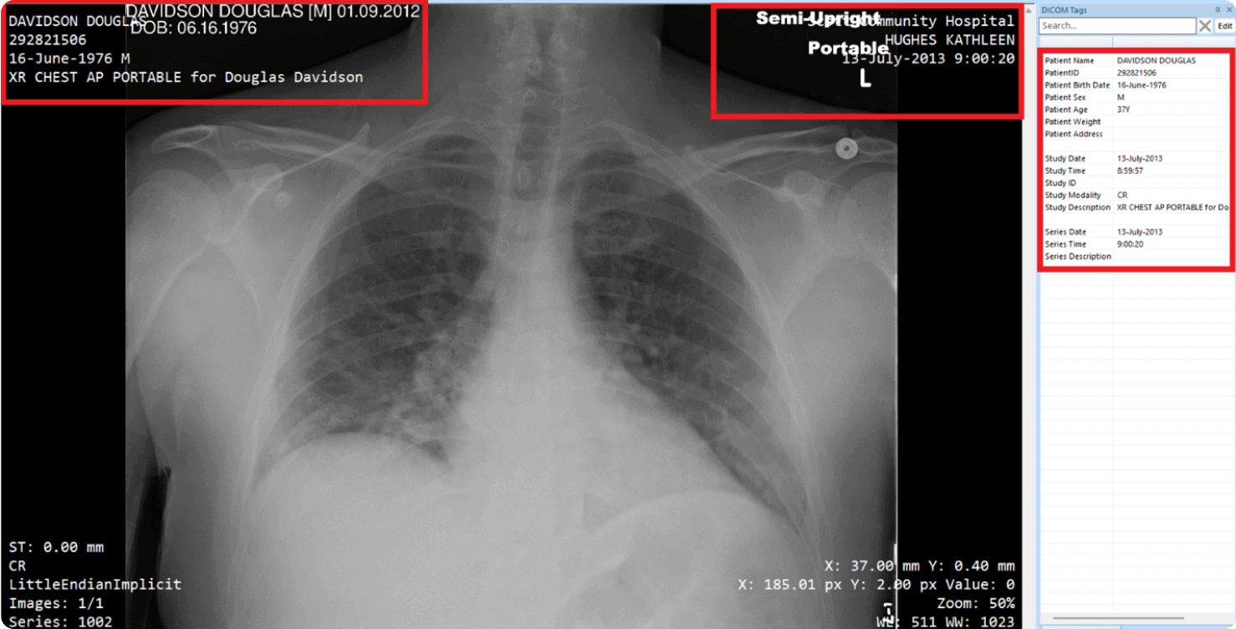
opswat.com
DICOM Anonymization: Enhance Data Security with OPSWAT Proactive ...
Figure 19: Additional burned-in annotation cleaning example in medical images (Shows region detection and masking.)

physicamedica.com
Data preparation for artificial intelligence in medical imaging: A ...
Evidence Artefacts for Repository
Place these in /docs/image_processing/ and /tests/:
- anonymizer.py: Full script with comments referencing PS3.15 tables (e.g., Annex E attributes).
- Sample logs: anonymization_log_sample.txt – showing processed tags, date shifts.
- Before/after headers: sample_before_header.txt and sample_after_header.txt (from public datasets like TCIA).
- Pixel cleaning demo: Screenshots or saved images showing original vs blacked-out regions.
- Test scripts: test_anonymizer.py (using public DICOM samples from pydicom datasets).
This pipeline ensures full traceability, minimal re-identification risk, and alignment with UK healthcare data governance. For assessors, include a README in the module explaining rationale and compliance mapping to PS3.15.

